# SPRING BOOT

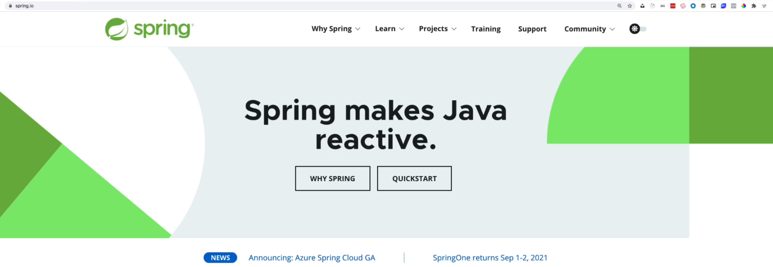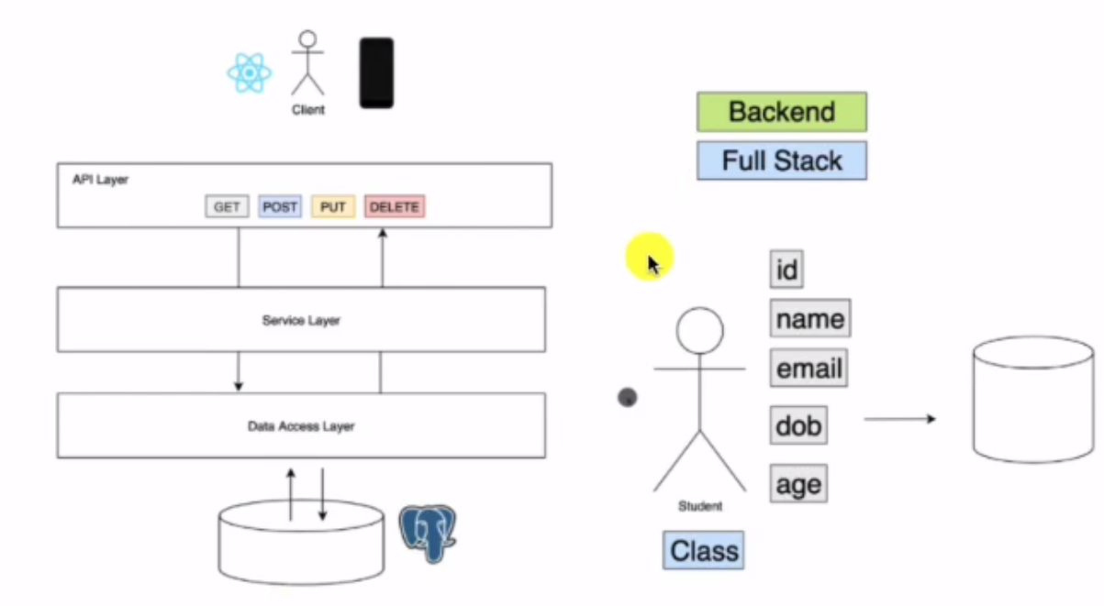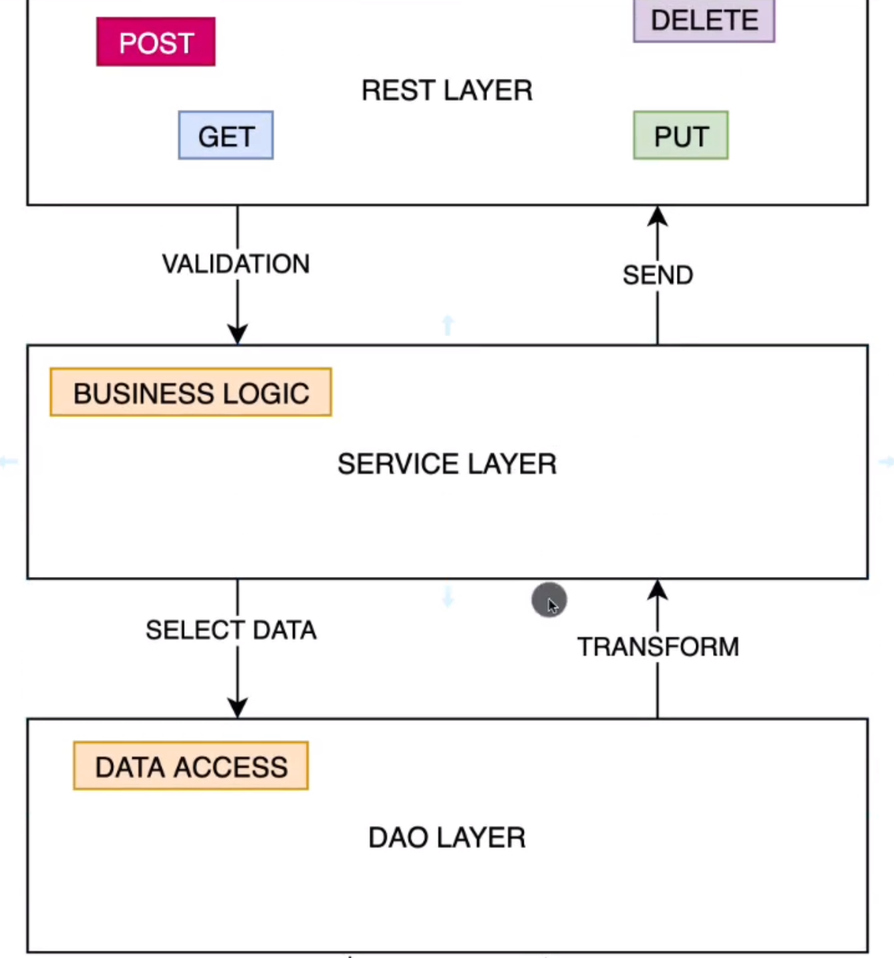

## Spring Boot devtools

<https://www.youtube.com/watch?v=BvIM9gNTDM4>

## Setting properties

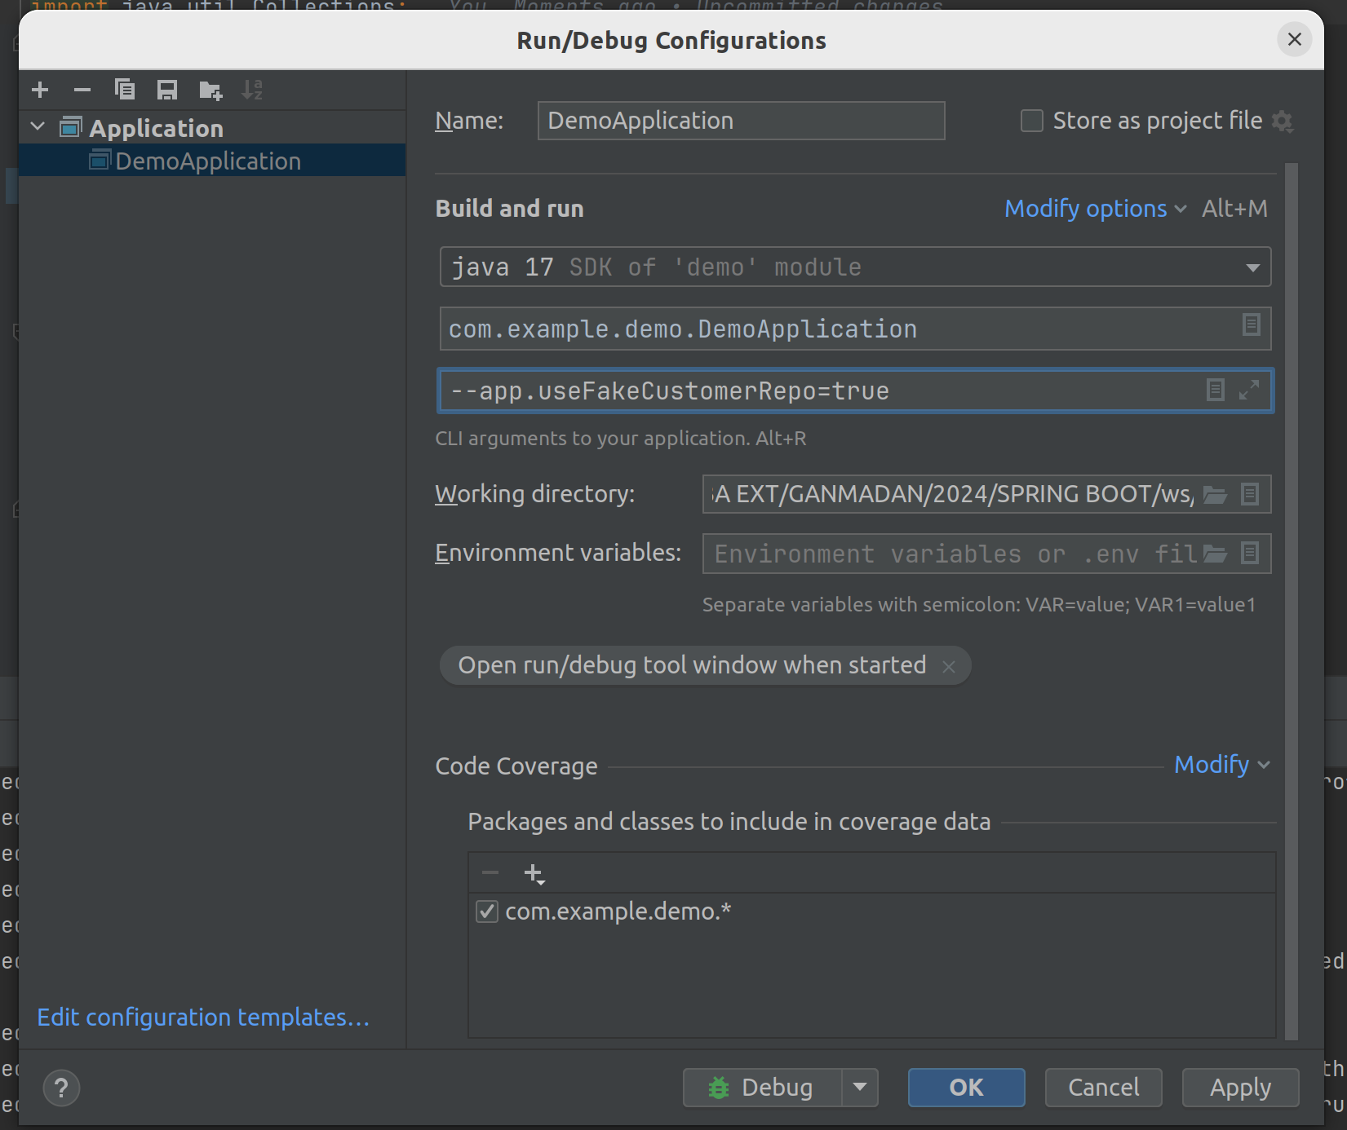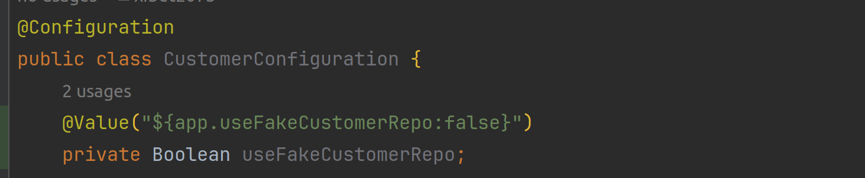

**:false** is a default value.

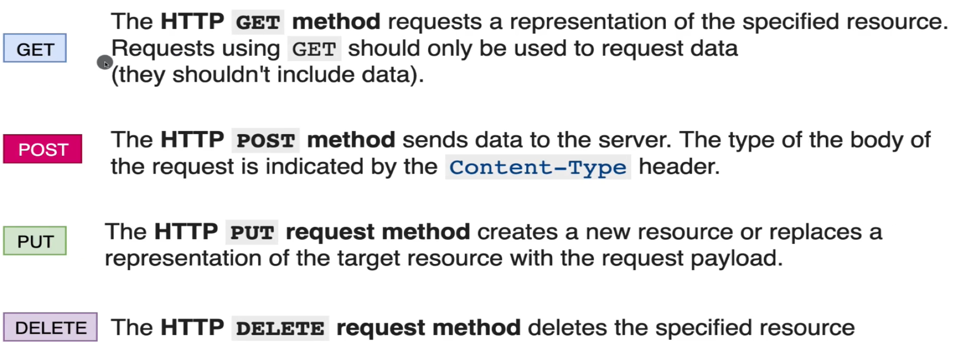

## Request body validation

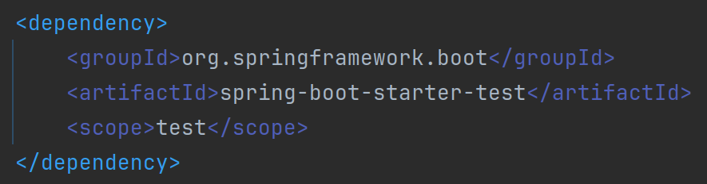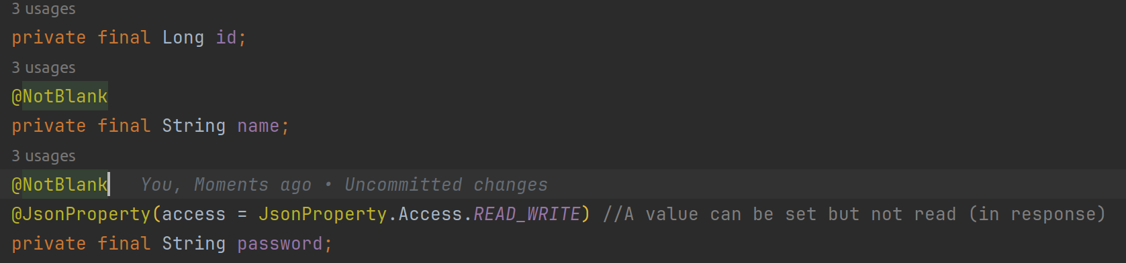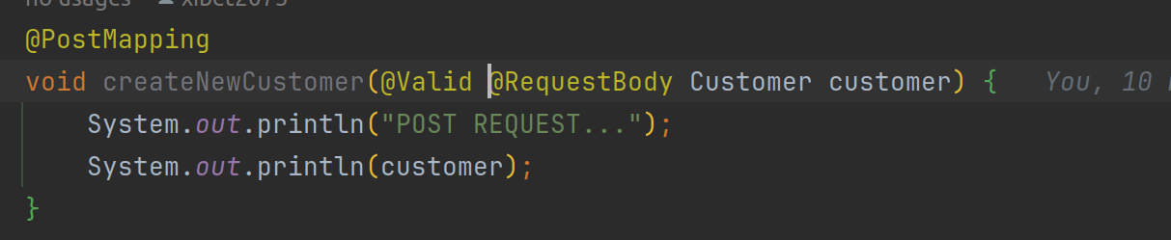

Errore che si verifica se vengono passati i campi non valorizzati.

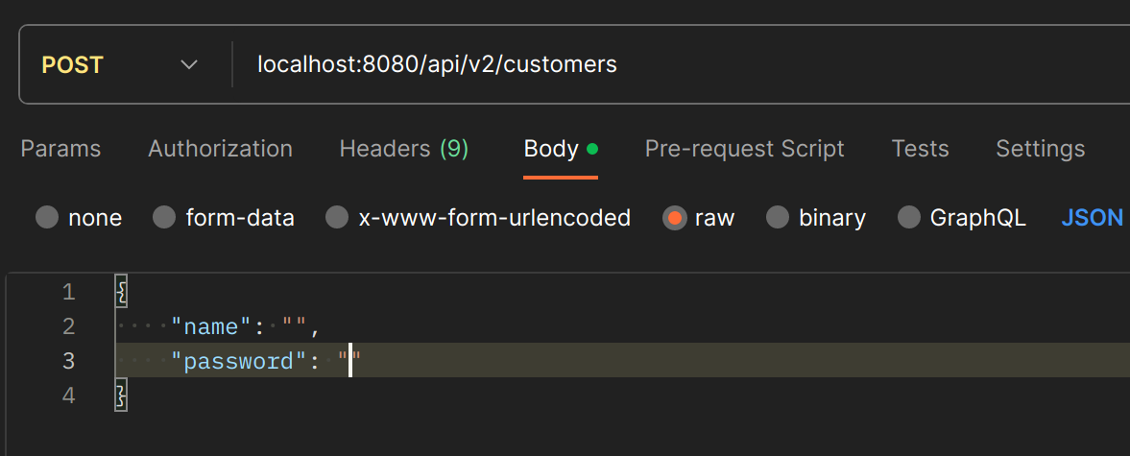

[Field error in object 'customer' on field 'password': rejected value [null]; codes [NotBlank.customer.password,NotBlank.password,NotBlank.java.lang.String,NotBlank];

## Exception handling

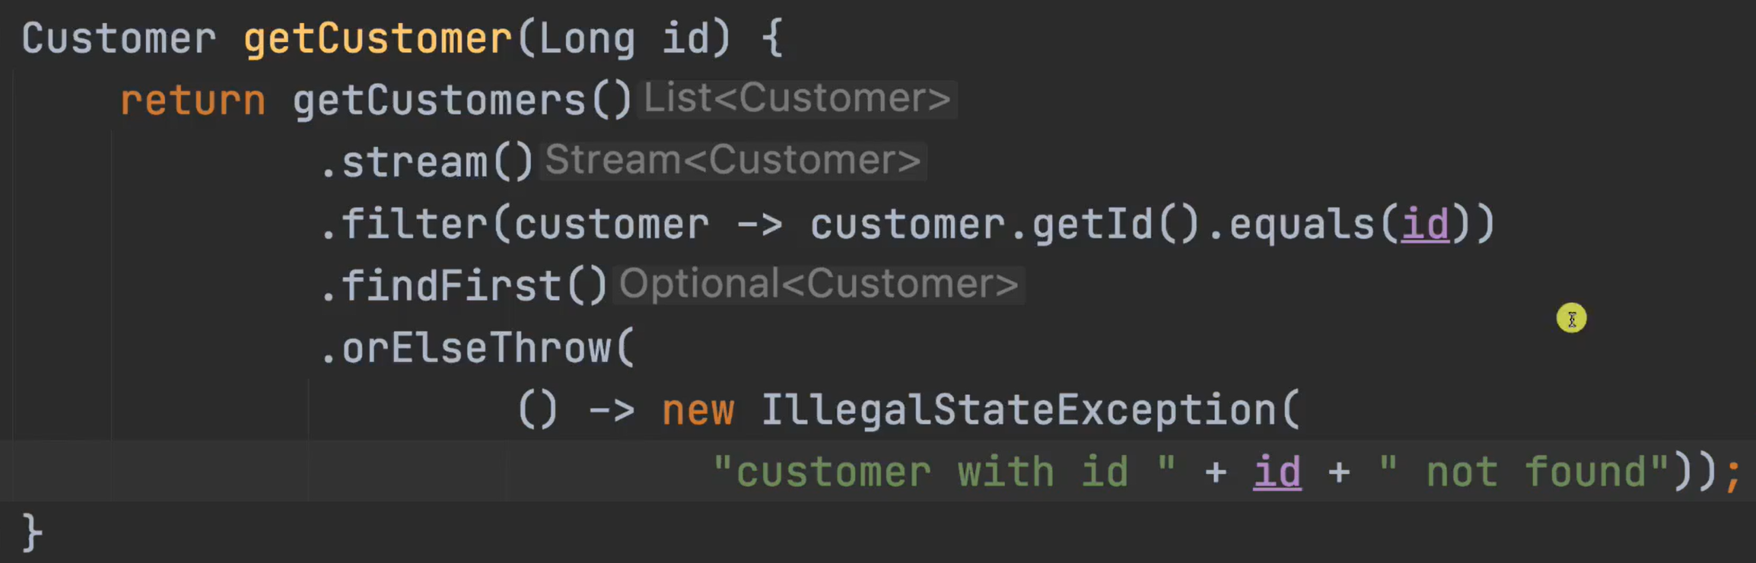

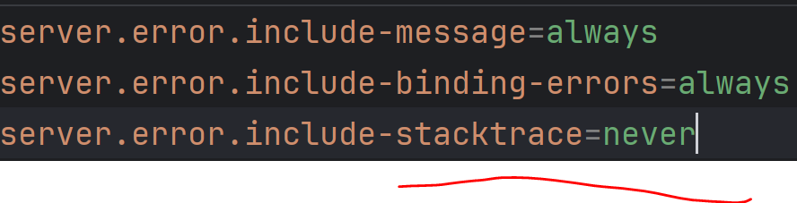

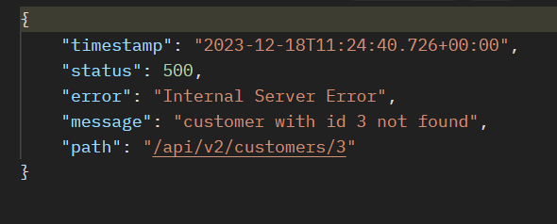

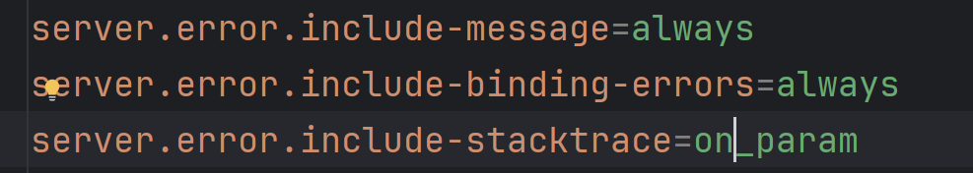

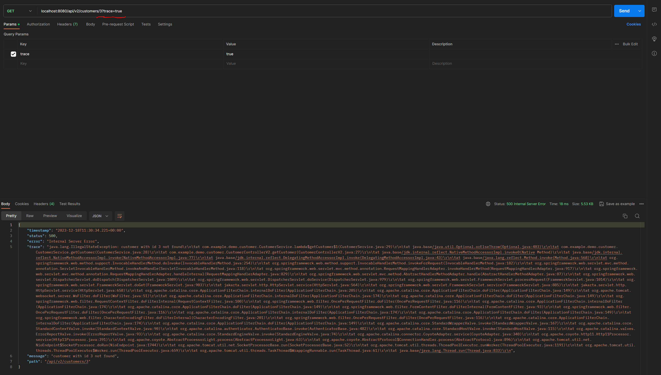

## Http response status codes

<https://developer.mozilla.org/en-US/docs/Web/HTTP/Status>

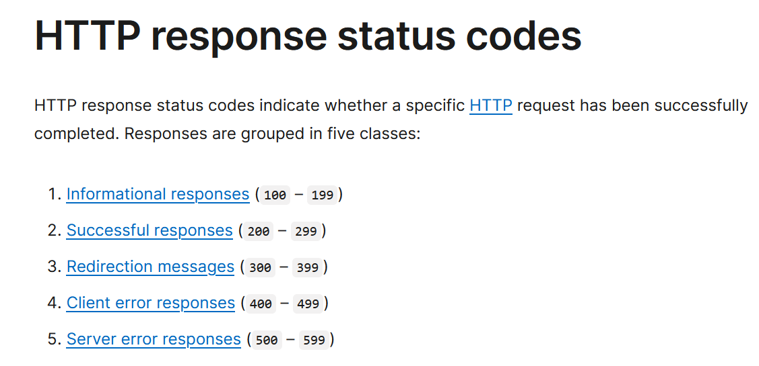

### Custom exception

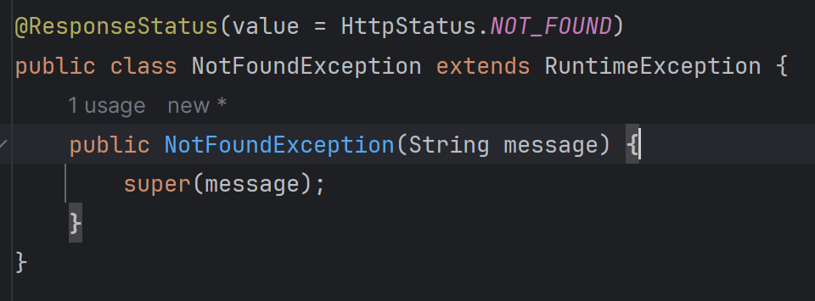

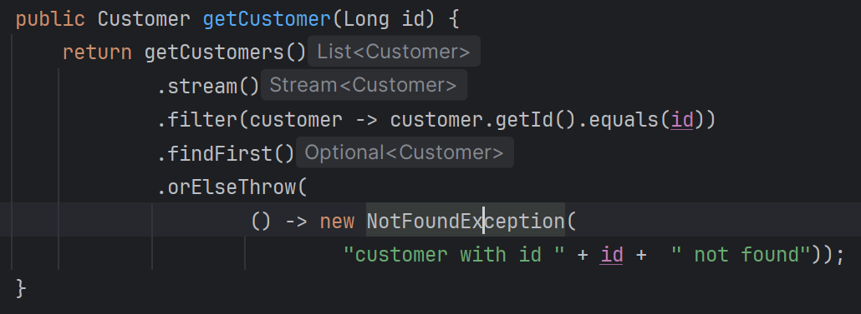

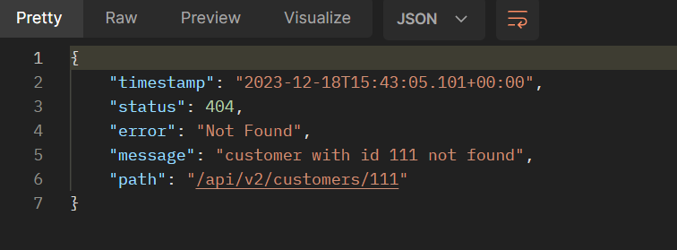

Spring Data   
<http://localhost:8080/h2>

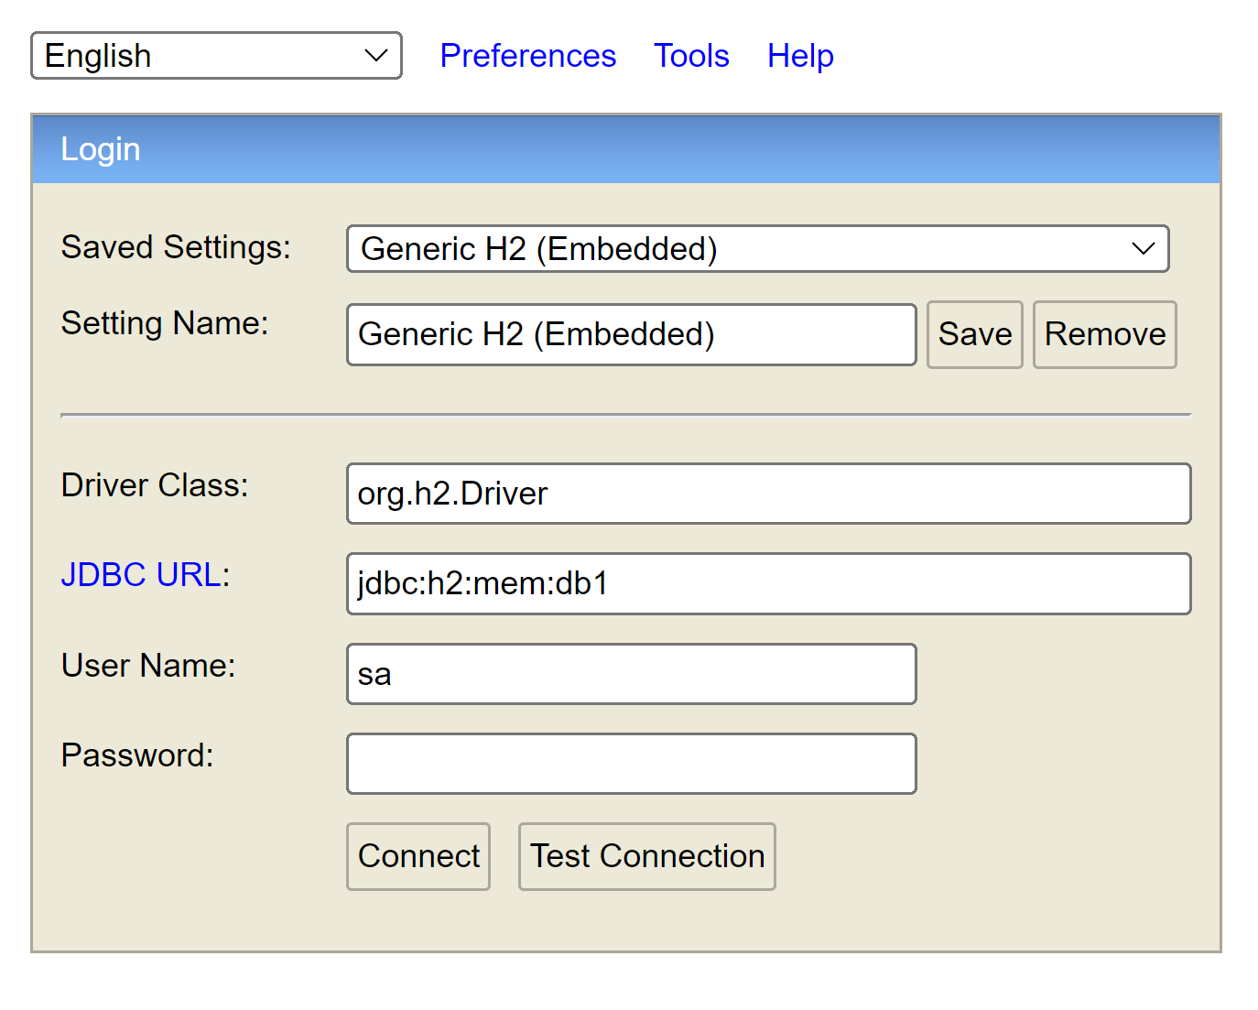

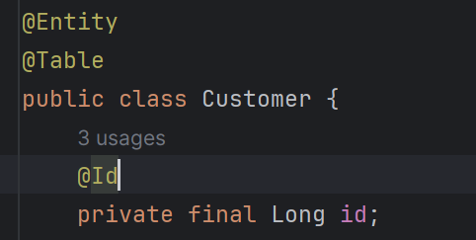

## Feign rest client

<https://github.com/OpenFeign/feign>  
<https://spring.io/projects/spring-cloud-openfeign>

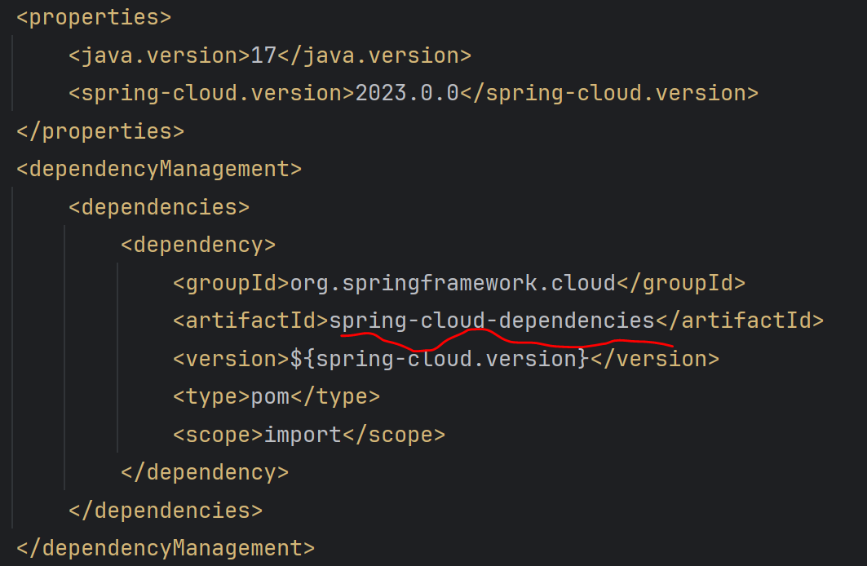

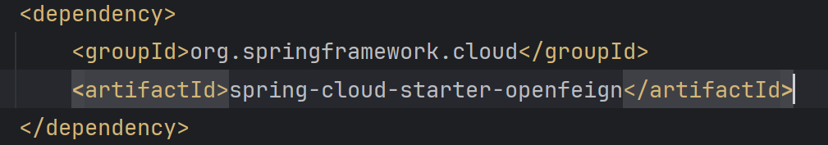

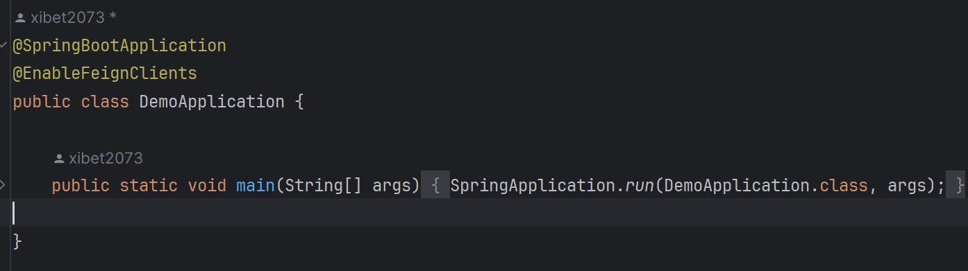

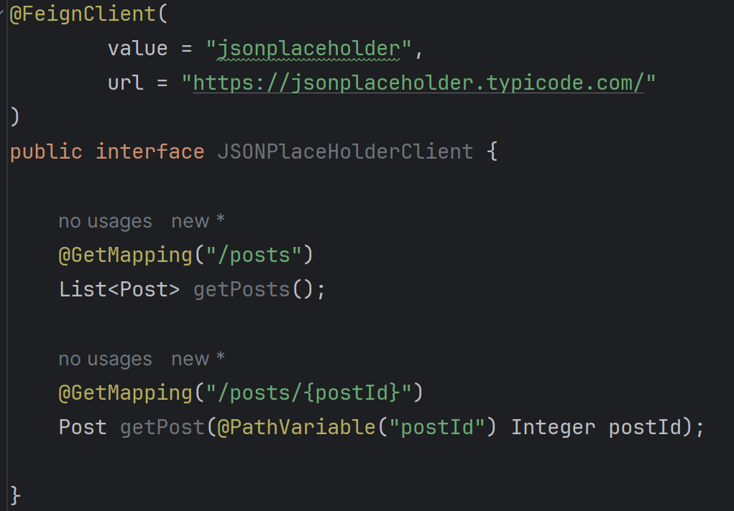

## JSONPlaceholder

<https://jsonplaceholder.typicode.com/>

## Logging

<https://docs.spring.io/spring-boot/docs/2.1.13.RELEASE/reference/html/boot-features-logging.html>

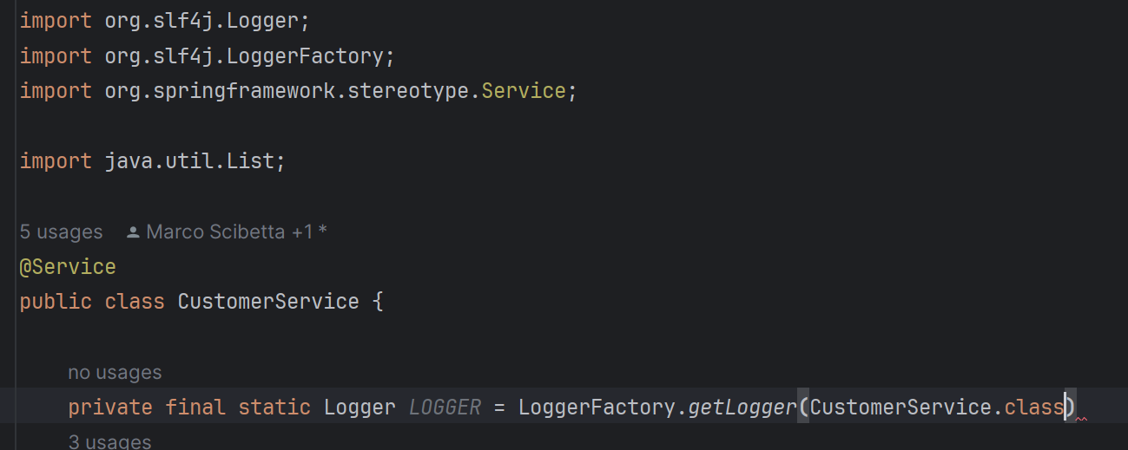

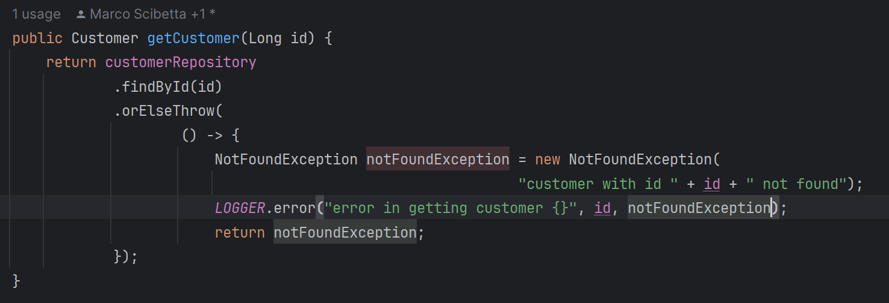

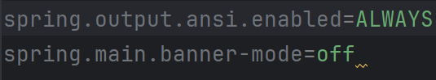

## Actuator

<https://docs.spring.io/spring-boot/docs/current/reference/html/actuator.html>

<https://grafana.com/>

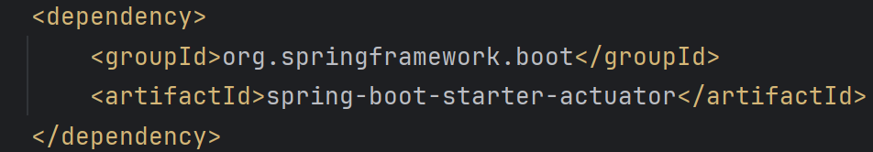



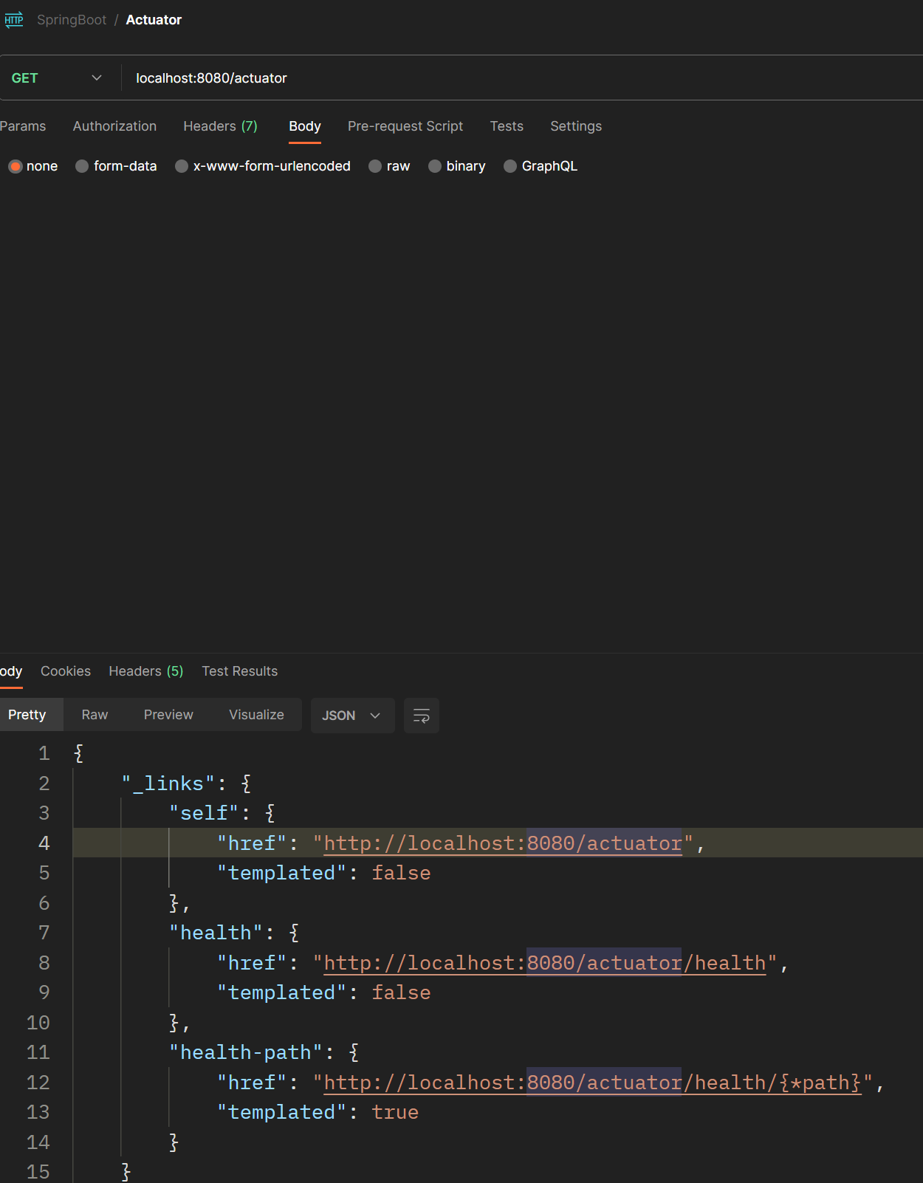

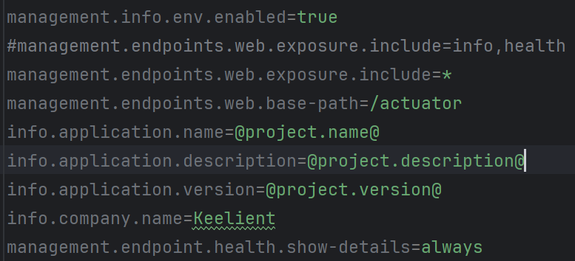

### Micrometer

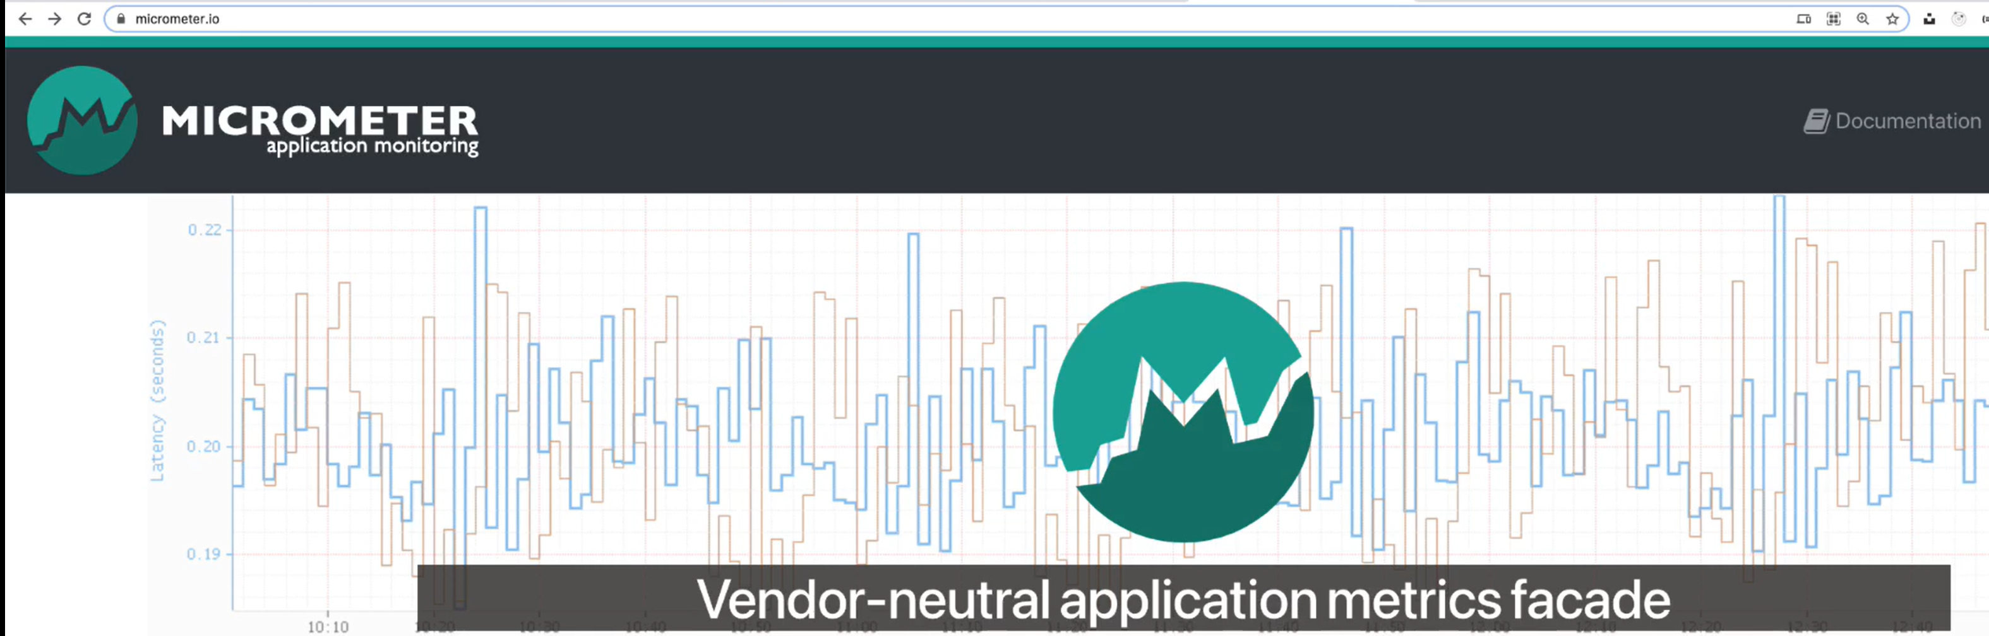

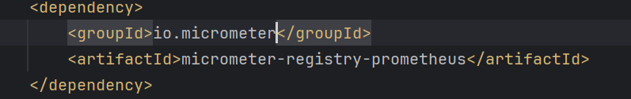

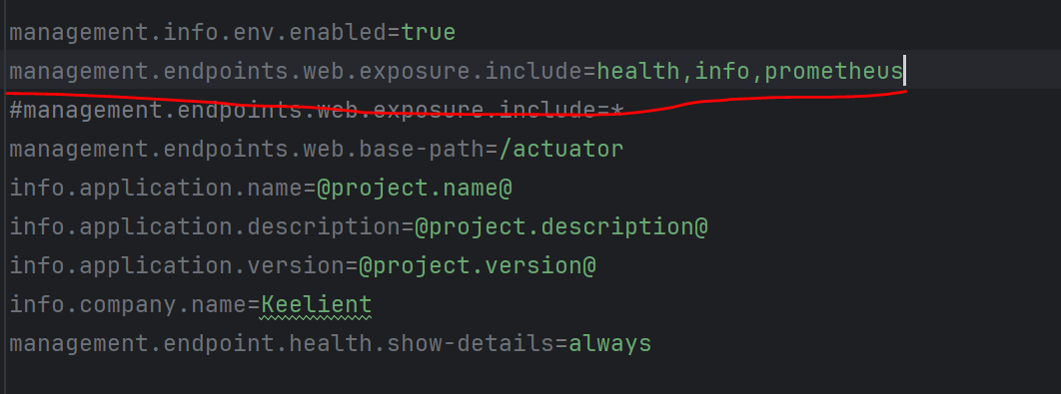

JVM metrics

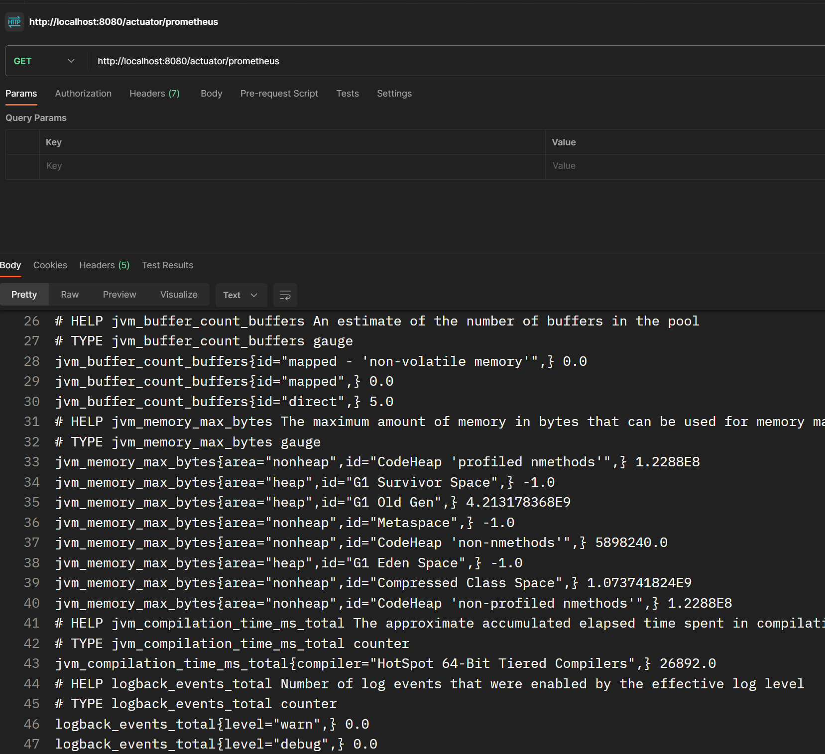

## Properties

### Setting properties programmatically

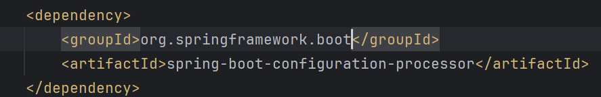

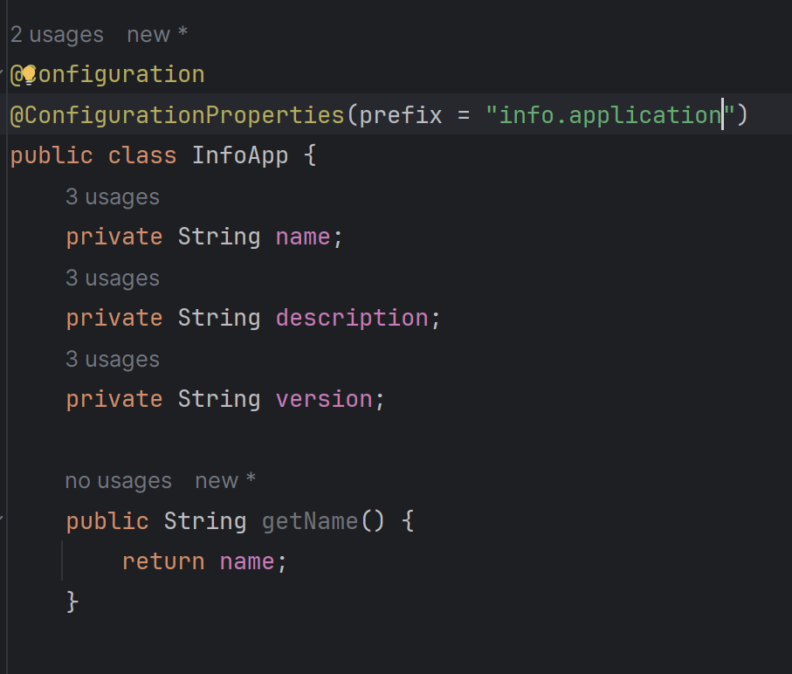

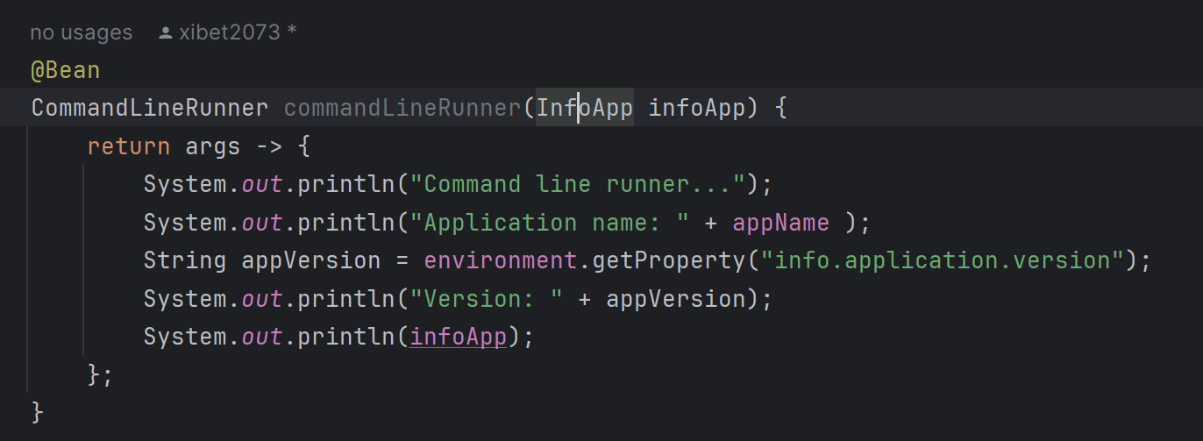

## Profiles

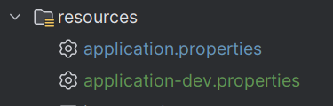

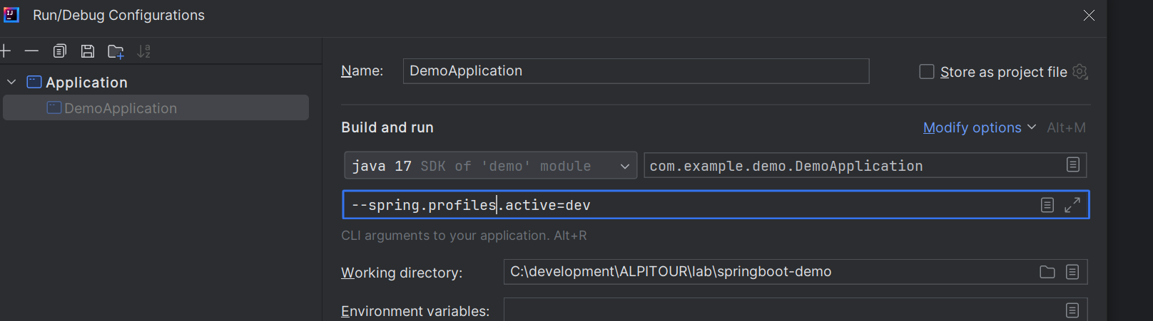

## Yaml properties file

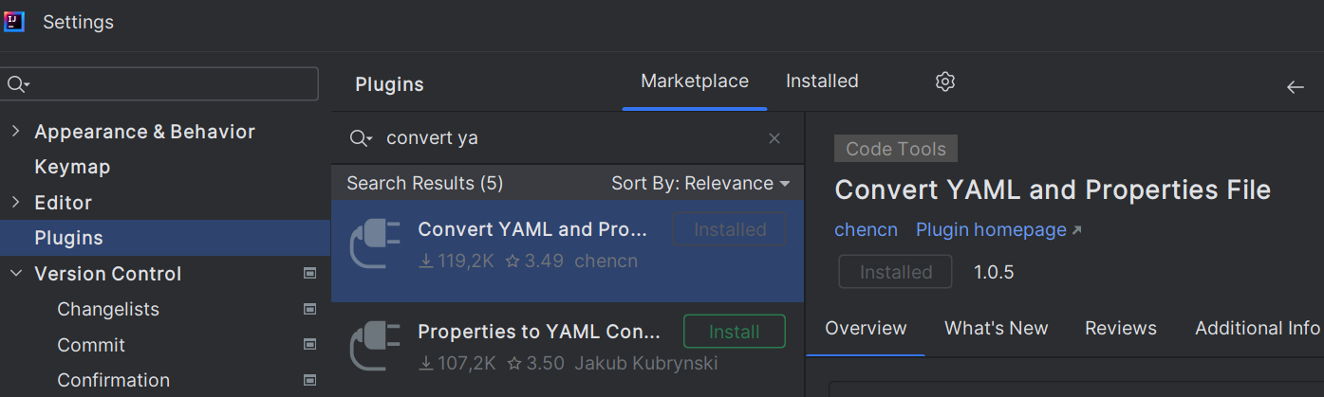

## Maven

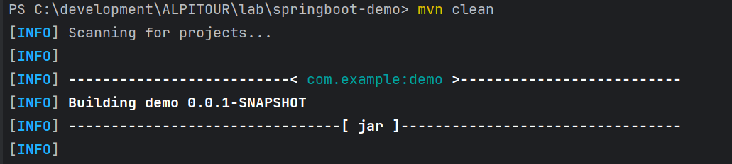

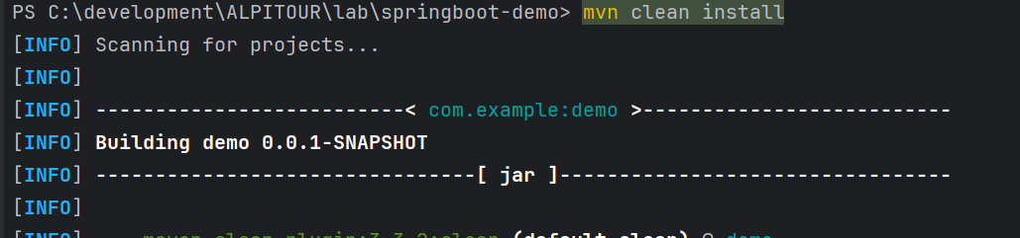





## Testing CTRL + SHFT + T

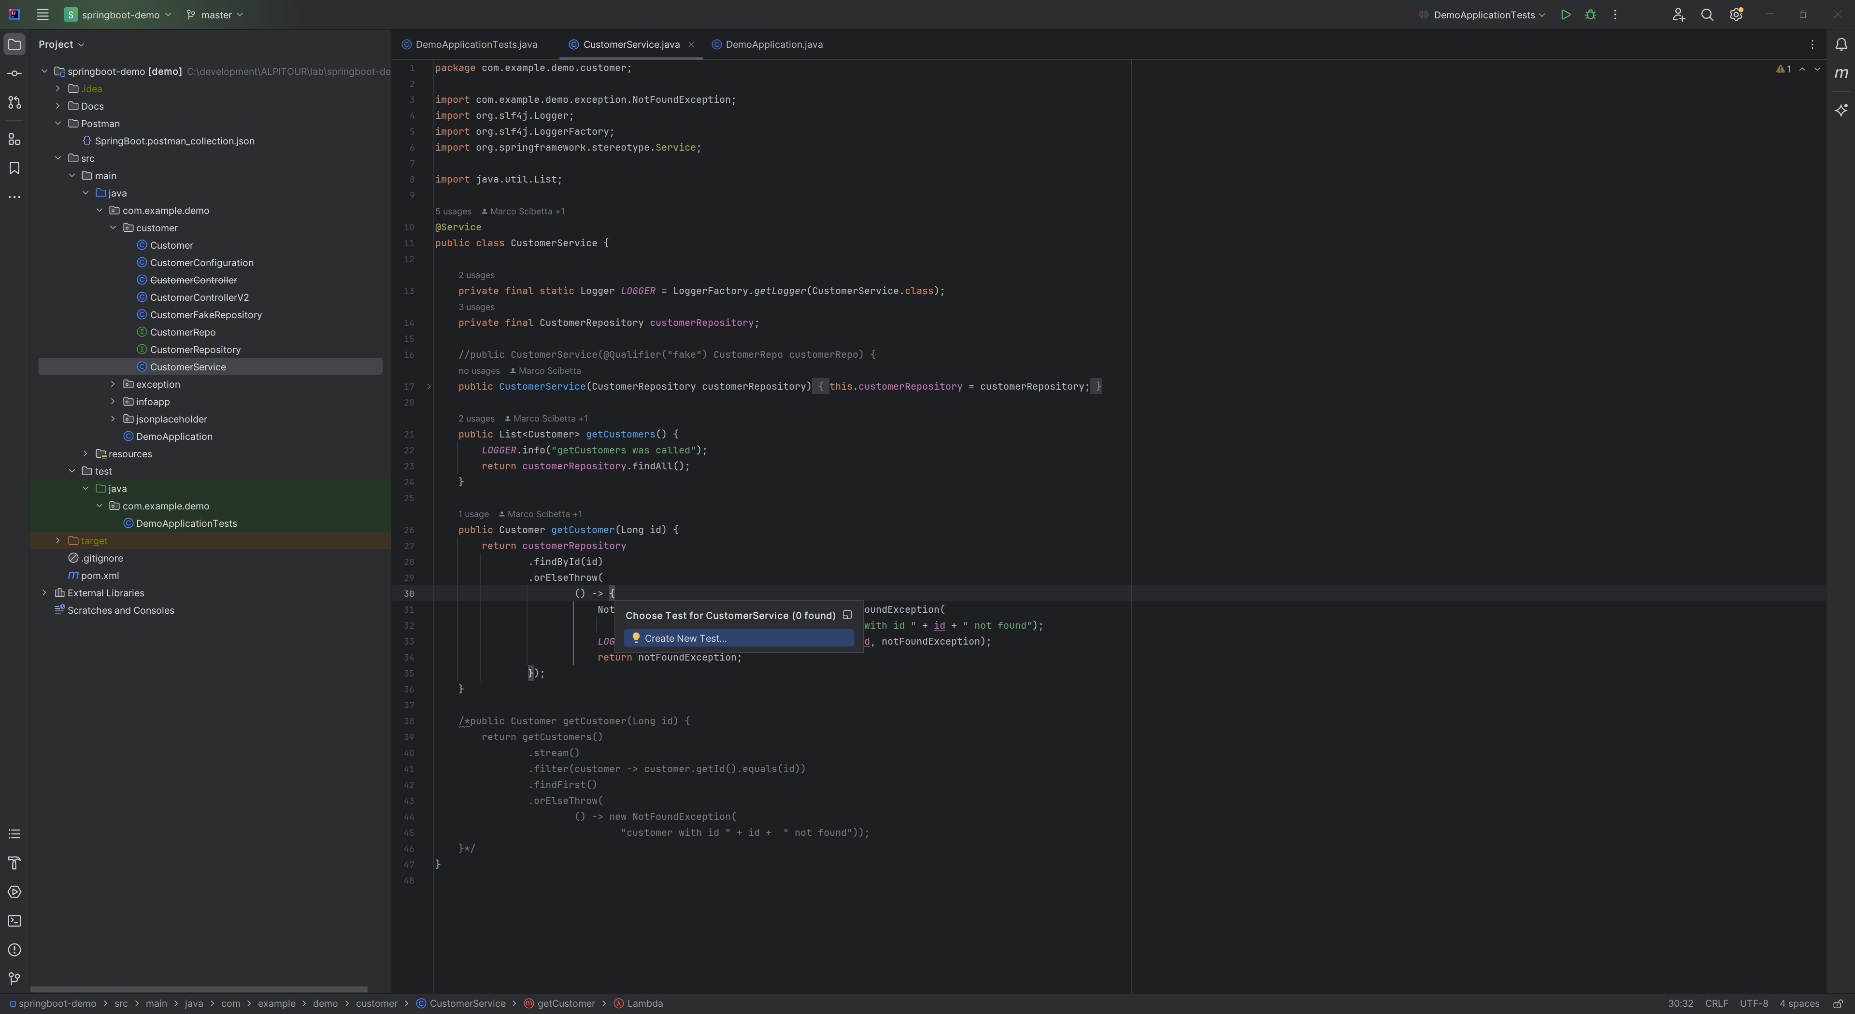

## Lombok

@Data annotation in Lombok is an aggregated annotation that includes the functionality of several other annotations. The annotations aggregated into @Data are @Getter, @Setter, @ToString, @EqualsAndHashCode, and @RequiredArgsConstructor

This means that when you use @Data on a class, it automatically generates getters for all fields, setters for all non-final fields, toString, equals, hashCode methods, and a constructor with all non-initialized final fields as arguments

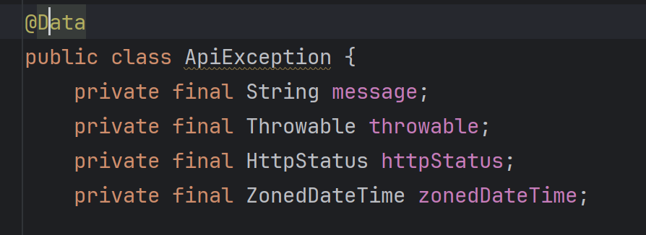

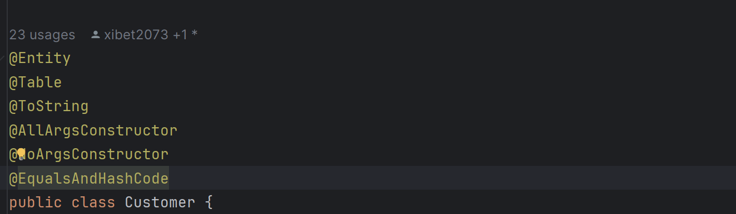

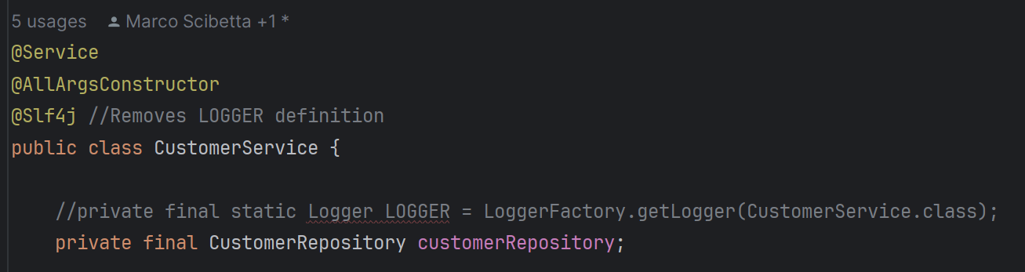

## Java Records

>>> 71

.